# Extract to Excel plugin

In order to automate the clustering processing used by KTH, the team has developed a QGIS-based plugin. This brief document will go through how to install the plugin and make it available for use in QGIS

1. Download the zipped folder onto your computer.
2. Open **QGIS Desktop** make sure that you use version 3.0 or newer.
3. On top of the window you have a number of menus, click on the one that reads **Plugins.**

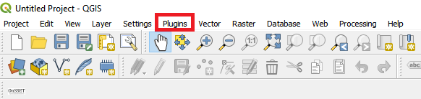

Figure 1. Plugin menu

1. Next, go to **Manage and Install Plugins…**

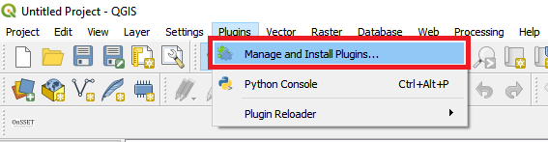

Figure 2. Mangaement menu for plugins

1. This will open a new window with a number of different options on the left-hand side. We will choose **Install from ZIP**

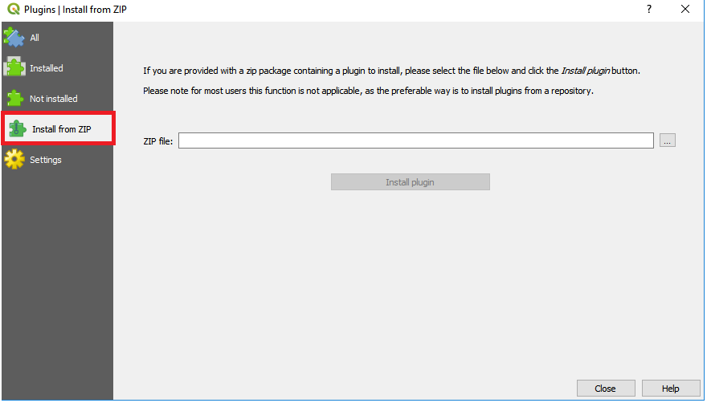

Figure 3. Installing plugins using ZIP-files

1. In the window that opens click on the three dots next to the empty field to navigate to wherever you saved the zipped plugin folder.

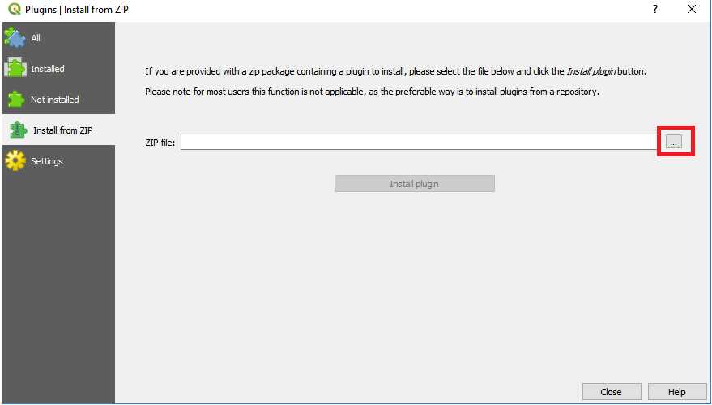

Figure 4. Click on this button to browse to the zipped file

1. When you have found it click **Install plugin**

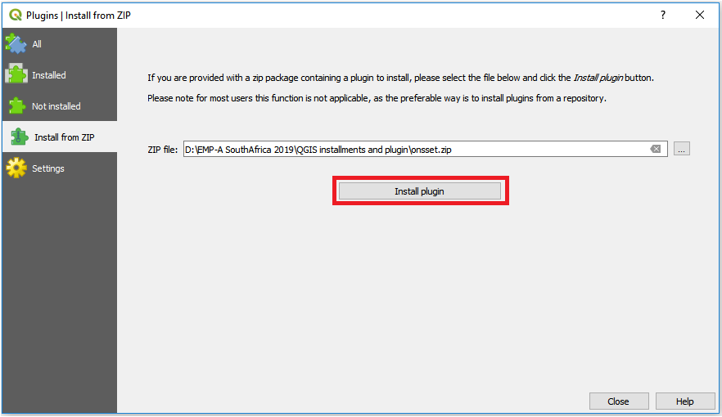

Figure 5. When you have found the zipped folder click on this button to install it

1. After the plugin has been installed will appear under the **Plugins** menu on top of the screen. You are now ready to run the plugin.

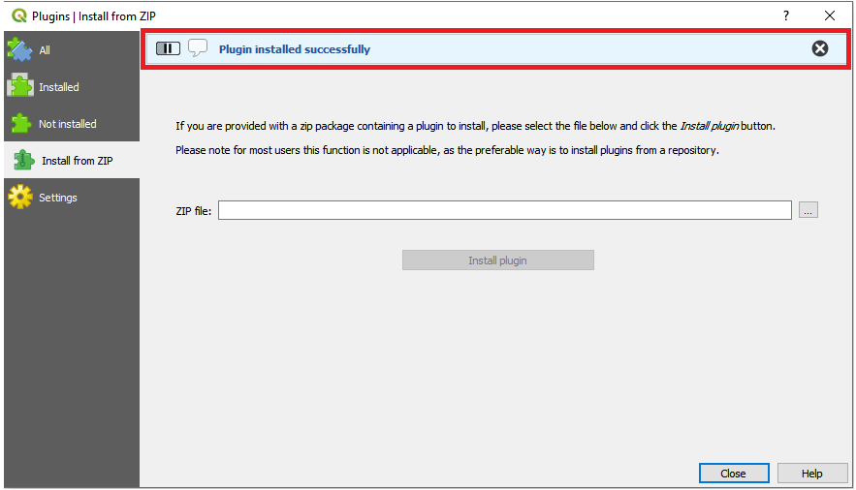

Figure 6. This field will appear when the install is completed

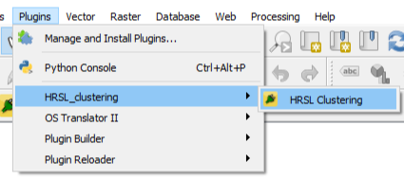

Figure 7. When the plugin is installed it will appear under the database menu with the name "HRSL_clusteringl"